PUBLIC NOTICE
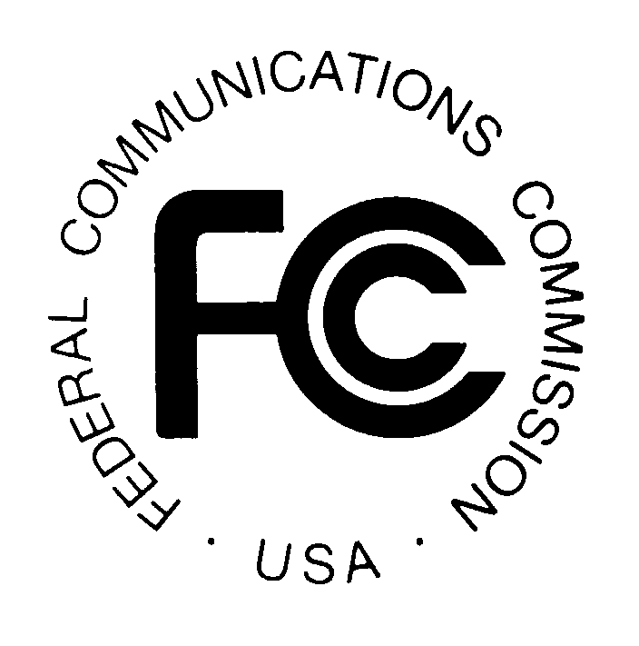
News media information 202 / 418-0500
Fax-On-Demand 202 / 418-2830
TTY 202 / 418-2555
Internet: http://www.fcc.gov
ftp.fcc.gov

Federal Communications Commission
445 12th St., S.W.
Washington, D.C. 20554

DA 04-134

January 23, 2004

WIRELESS TELECOMMUNICATONS BUREAU

NEW ENGLAND (REGION 19) 700 MHz PUBLIC SAFETY
PLANNING COMMITTEE ANNOUNCES PLANNING MEETING

The New England (Region 19) 700 MHz Public Safety Planning Committee announces that its next meeting will be held on Tuesday, March 9, 2004 at 10:00 a.m., at the Massachusetts State Police General Headquarters, 470 Worcester Road, Framingham, Massachusetts.

The purpose of this meeting is to continue developing a Regional Plan to meet the needs of the 700 MHz and 4.9 GHz spectrum users including Public Safety, Public Health, Emergency Management and Utility services.

The Region 19 700 MHz Public Safety Planning Committee meeting is open to the public. All eligible public safety providers whose sole purpose or principal purpose is to protect the safety of life, health, or property in the States of Massachusetts, Rhode Island, Maine, Vermont, New Hampshire, and Connecticut would utilize these frequencies. It is essential that participants be representatives of all eligible public safety providers in order to ensure that each agency’s future spectrum needs are considered in the allocation process. Administrators who are not oriented in the communications field should delegate someone with this knowledge to attend, participate and represent their agency’s needs.

All interested parties wishing to participate in the planning for the use of new public safety spectrum in the 700 MHz band and/or the newly allocated 4.9 GHz band within Region 19 should plan to attend. For further information, please contact:

George J. Pohorilak, Chairman
Region 19, 700 MHz Public Safety Planning Committee
Division of Fire, Emergency and Building Services
1111 Country Club Road
Middletown, CT 06457-9294
(860) 685-8108 (voice)
(860) 685-8363 (fax)
Email: george.pohorilak@po.state.ct.us
Website: www.ner700mhz.org

or

Jerry Zarwanski, Vice-Chairman
Department of Public Safety
Division of Fire, Emergency and Building Services
P.O. Box 2794
Middletown, CT 06457-9294
(860) 685-8157 (voice)
(860) 685-8363 (fax)
Email: jerry.zarwanski@po.st.us

--FCC--

